Student’s name | …………………………………………………….…… | Grade | 6
Subject | Computer | Week No. | 14
Lesson Title | Cloud Computing | Unit
Worksheet No. ( 14 )

Question A: write the correct name of each part.

Server | Cat | Clients
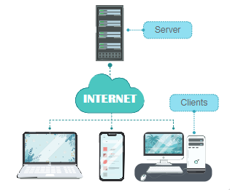
Good Luck

